Nauka dla społeczeństwa

Katedra i Zakład Informatyki i Statystyki

dr Justyna Marcinkowska

data przygotowania: 2024-05-05

Zalecenia dotyczące warsztatów – część 8 – kod wykresów w R cd. :

*Ilustracja graficzna*

*w publikacji naukowej*

*(język R)*

# Ćwiczenia praktyczne na warsztatach:

• Omówienie podstawowej składni języka R,

• Przygotowanie do pracy z danymi: import, tworzenie data frame,

• Wstęp do analizy danych i graficznej wizualizacji:

* przetwarzanie i analiza danych (biblioteka dplyr),
* tworzenie bogatych graficznie, typowych i nietypowych wykresów na podstawie warstw (biblioteka ggplot2)

• Przygotowanie wykresów pod wymogi czasopism naukowych, eksport wykresów wysokiej rozdzielczości



sodium %>%   
 filter(hospitalization == 1, !is.na(department)) %>%  
ggplot(aes(x=department, y=sodium_concentration)) +  
 geom_violin(scale="width", aes(fill=department), color="white", alpha=0.4)

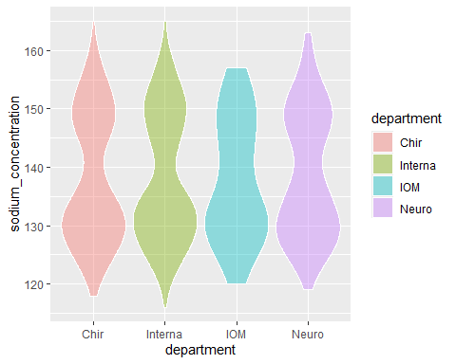

q3 <- function(x) {  
 a <- quantile(x, c(0.25,0.5,0.75))  
 names(a) <- c("ymin", "y", "ymax")  
 a  
}  
  
  
sodium %>%   
 filter(hospitalization == 1, !is.na(department)) %>%  
ggplot(aes(x=department, y=Stay_in_the_Emergency_Department)) +  
 geom_violin(scale="width", aes(fill=department), color="white", alpha=0.4) +  
 stat_summary(  
 fun.data = "q3",   
 geom = "crossbar",  
 colour = "red",   
 width = 0.5,  
 position = position_dodge(width = 0.75)  
 )+  
 geom_point(  
 stat = "summary",   
 fun = "mean",  
 color = "darkred",   
 size = 5,   
 position = position_dodge(width = 0.75)  
 )

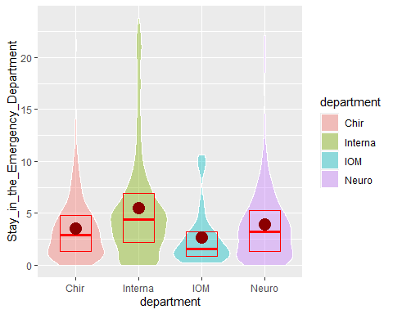

sodium %>%   
 filter(hospitalization == 1, !is.na(department)) %>%  
ggplot(aes(x=department, y=Stay_in_the_Emergency_Department)) +  
 geom_violin(scale="width", aes(fill=department), color="white", alpha=0.4, show.legend = FALSE) +  
 geom_point(  
 aes(color = cut(age,   
 breaks = c(0, 40, 80, 100),   
 labels = c("0-40", "41-80", "81-100"))  
 ),   
 position = position_jitter(  
 width = 0.4),   
 size = 1.5,  
 alpha = 0.4 # Dodanie przezroczystości punktów  
 ) +  
 scale_color_manual(  
 values = c("0-40" = "blue", "41-80" = "green", "81-100" = "orange")  
 ) +  
 theme(legend.position = "bottom") +  
 guides(color = guide_legend(title = "Age"))

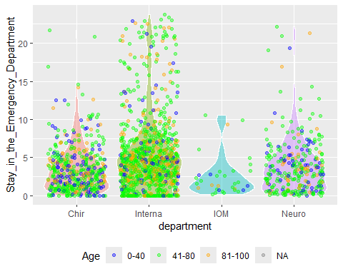

sodium %>%   
 filter(hospitalization == 1, medical_transport==0,!is.na(department)) %>%  
ggplot(aes(x=department, y=Stay_in_the_Emergency_Department)) +  
 geom_violin(scale="width", aes(fill=department), color="white", alpha=0.4, show.legend = FALSE) +  
 geom_point(  
 aes(color = cut(sodium_concentration,   
 breaks = c(0, 129, 135, 144,150,170),   
 labels = c("very low values",  
 "below standard",  
 "standard",  
 "above normal",  
 "very high values"))  
 ),   
 position = position_jitter(  
 width = 0.4),   
 size = 1.5,  
 alpha = 0.4 # Dodanie przezroczystości punktów  
 ) +  
 scale_color_manual(  
 values = c("very low values" = "red","very high values"="black")  
 ) +  
 theme(legend.position = "bottom") +  
 guides(color = guide_legend(title = "Sodium concentration")) +  
 facet_wrap(~sex,ncol=1)

Warning: Groups with fewer than two datapoints have been dropped.  
ℹ Set `drop = FALSE` to consider such groups for position adjustment purposes.

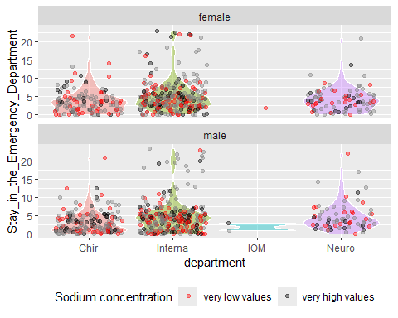

# Utwórz factor z wiekiem  
sodium$age_group <- cut(sodium$age, breaks = c(0, 60, 80, 120), labels = c("<=60", "61-80",">80"))  
story2<-  
sodium %>%   
 filter(hospitalization == 1, medical_transport==0,!is.na(department)) %>%  
ggplot(aes(x=age_group, y=Stay_in_the_Emergency_Department)) +  
 geom_violin(scale="width", aes(fill=age_group), color="white", alpha=0.4, show.legend = FALSE) +  
 theme(legend.position = "bottom") +  
 guides(color = guide_legend(title = "Dangerous sodium concentrations"))+   
 labs(x = "Patient age groups", y = "How long did they stay in the Emergency Department?") +  
 facet_wrap(~sex,ncol=1)  
  
ggsave(plot=story2,filename='sodium_concentration_story2.jpeg',dpi=300, scale=2, width=6)

Saving 12 x 8 in image

print(story2)

